Harvest Giving

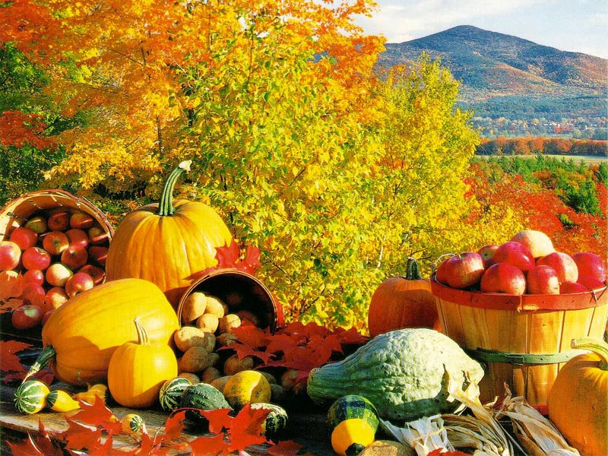

**Emmanuel Episcopal Church’s Fall Harvest food drive**.

The Rev. Don C. Youse Jr. Vicar

Beginning September 15th - November 10, 2019

All food donations will be given to the ‘Northside Common Ministries’

Donations can be brought to Church at Sunday service times.

More information call Patty Veal-Cislon @ 704-516-7645